https://www.youtube.com/watch?v=NNFJREcalc0
Domain Driven Design is a way of looking at software from top down

When we are developing a software our focus shouldn’t be primarily on technology , it should be primarily on business or whatever activity we are trying to assist with the software, the domain

Specifically we approach that by trying to develop models of that domain and make our software conformed to that

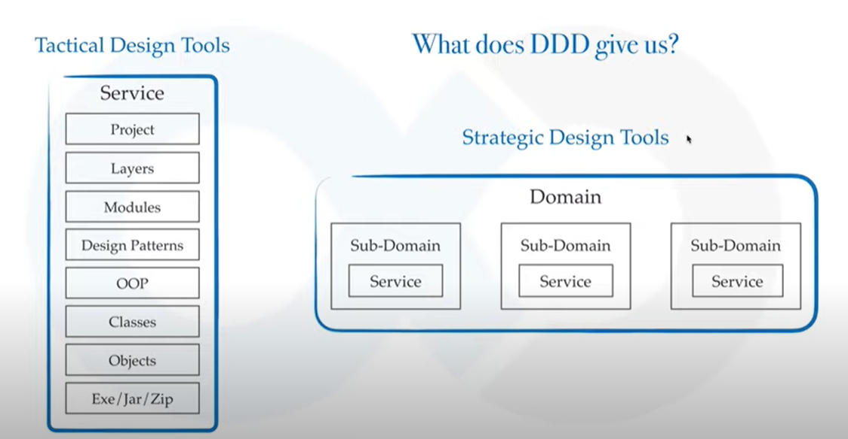

https://www.youtube.com/watch?v=Evers5npkmE

Object Oriented Design : Think in terms of Objects
Strategic Design : Think in terms of Contexts

What is Context?
The setting in which a word or statement appears that determines its meaning

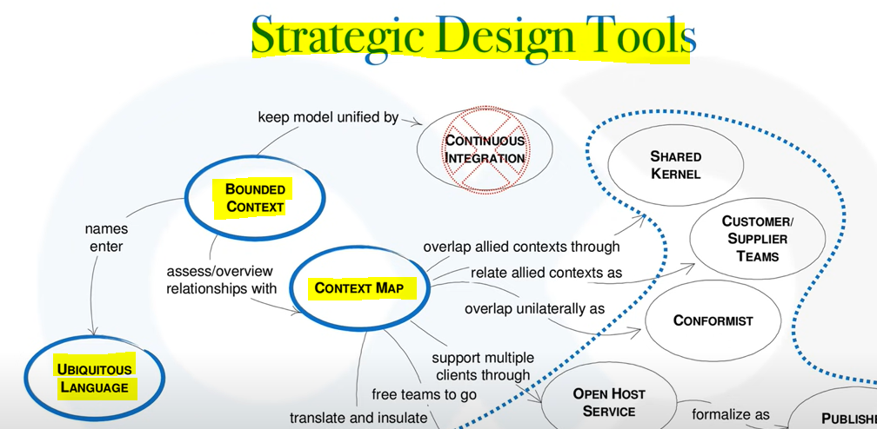

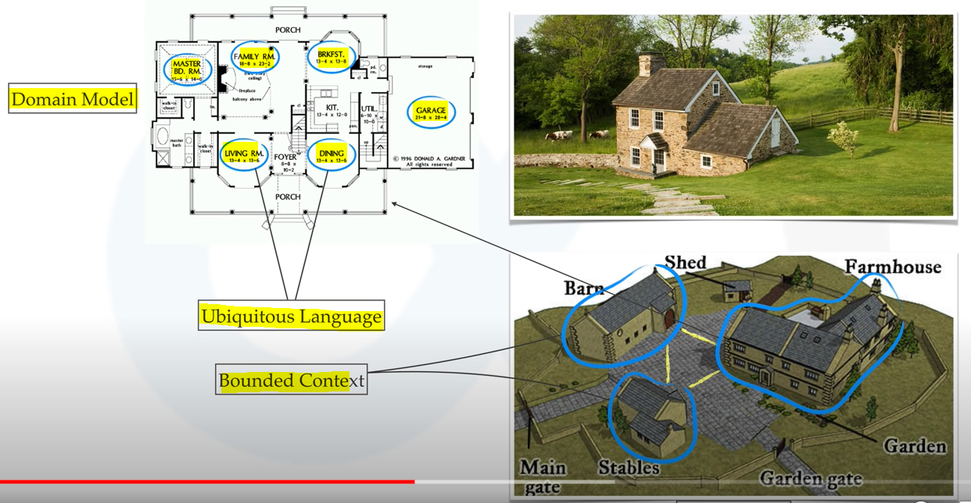

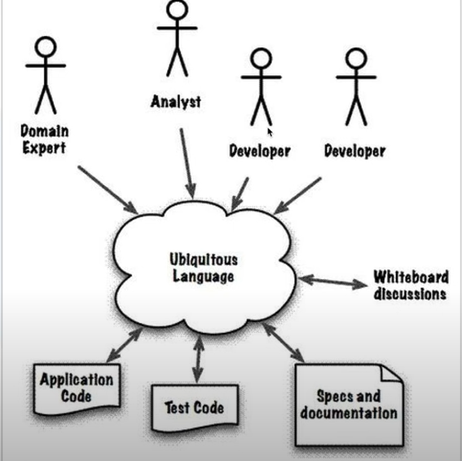

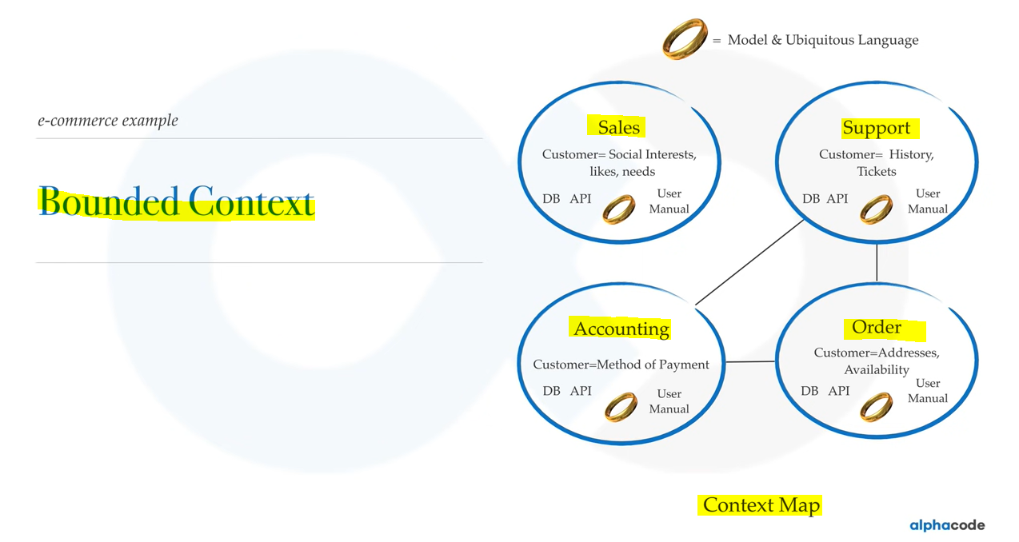

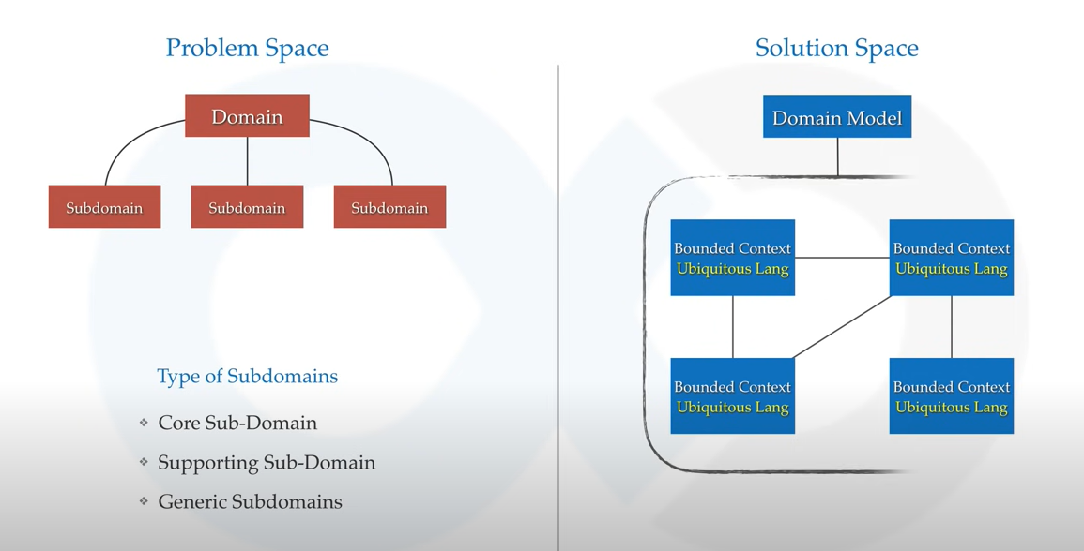
https://www.youtube.com/watch?v=WZb-FPmiuMY
What are Tactical Design Tools?
Tactical design tools are concerned with implementation details
Generally takes care of components inside a bounded context
A de facto standard in development world
You might have heard or used things like services , entities , repositories , factories , they’ve all been made popular by DDD
Contrary to strategic design , tactical design is expected to change during product development

In reality each Bounded Context will have it’s own micro services

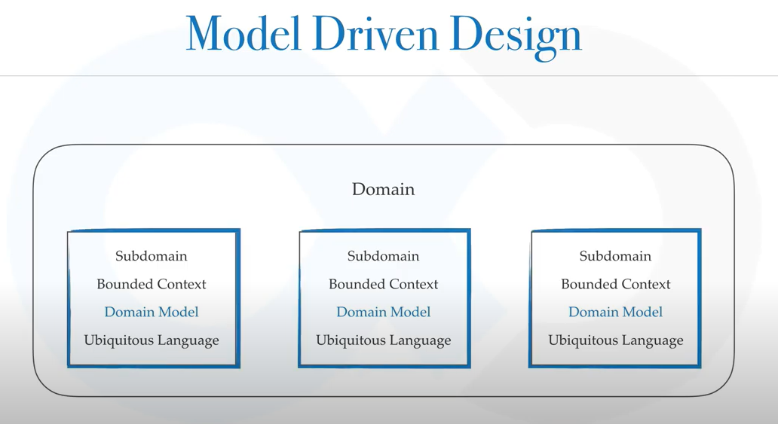

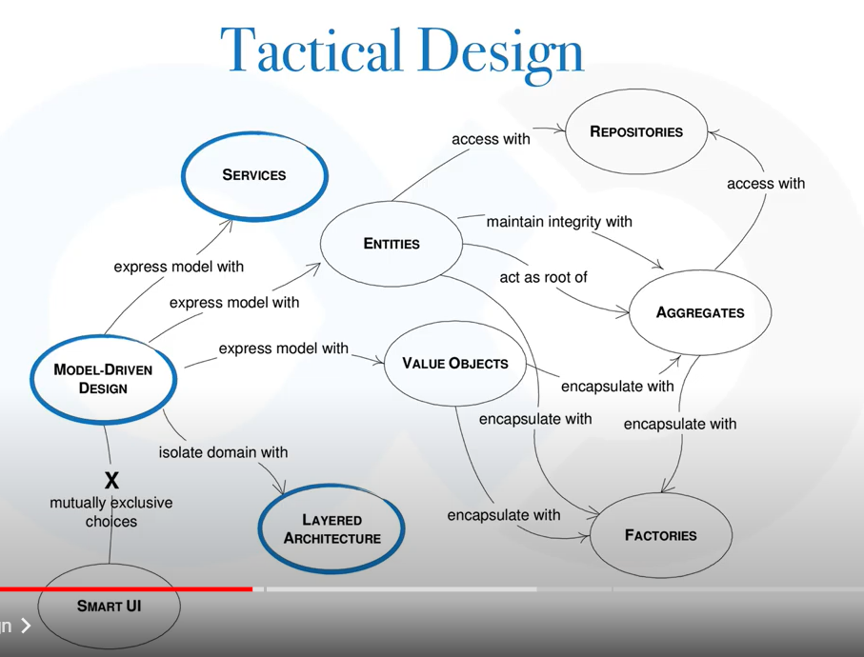

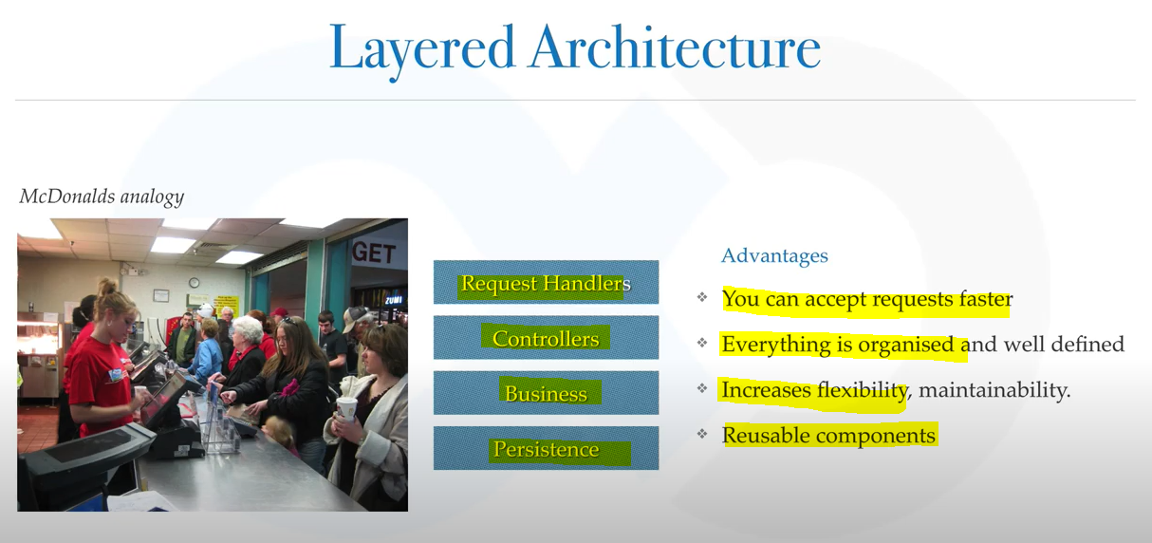

https://www.c-sharpcorner.com/UploadFile/dev4634/introduction-to-domain-driven-design/
Domain Driven Design is all about understanding the customer real business need. We have heard of different domains such as Banking, Telecom, Supply chain, health care, etc .So here domain means the business knowledge about that particular industry. Similarly domain driven design is something which focuses more into the business need not focusing on the technology.
We are about to start to write a system, here we first try to understand exactly what customer is looking for, what business they are going to do with the new set of applications in the system. During the initial phase you don’t even think about architecture or programming. Your prime goal is to understand all the terms of business that customer uses and how he/she models the requirement domain.
So what we follow is that the customer discuss each business case in business meetings. Domain driven design purely based on these assumptions to map the business requirement into domain model.
Concepts of Domain Driven Design
Context
Contexts are portions of the solutions space. The setting in which a word or statement appears that determines its meaning.
Domain
The subject area to which the user applies a program is the domain of the software. It is also termed as sphere of knowledge. In a banking system the following are the highlighted domain models.
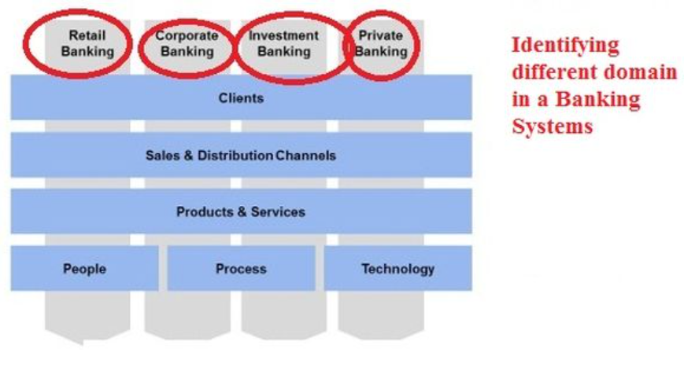
Model
A system of abstractions that describes selected aspects of a domain and can be used to solve problems related to that domain. The Domain Model itself could be a diagram, code examples or even written documentation of the problem. The important thing is, the Domain Model should be accessible and understandable by everyone who is involved with the system.
Domain Expert
Domain expert is a person who is an owner in a particular area or topic.
Consider a banking system there can be different domains such as Retail Banking, Corporate Banking, Home Lending, Investment Banking, Insurance, cards services, ATMS are of different type of domains. One dedicated person with expertise to a specific domain will be responsible to handle end to end business deliverables and solutions what a business need. Domain experts works closely with developers, end user, project management to successfully deliver a system.
Ubiquitous Language
Ubiquitous language is a language communicated around the domain model and used by all team members to connect all the activities of the team with the software.
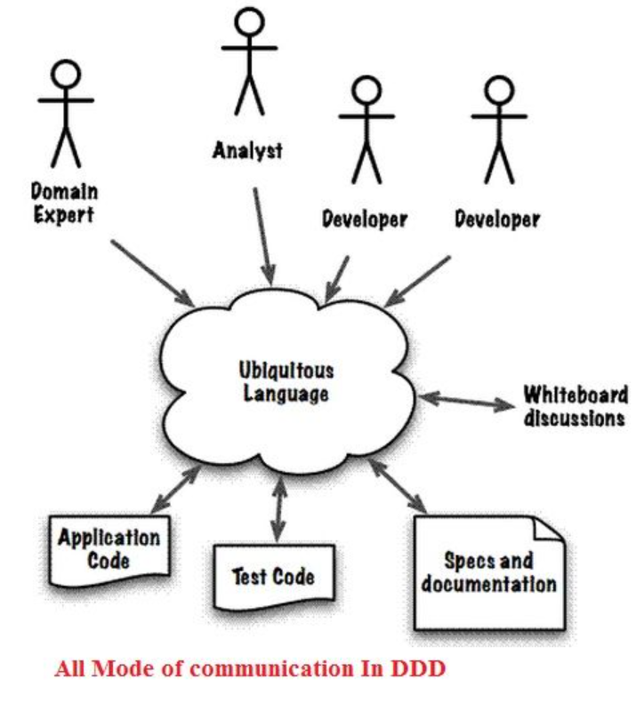
Bounded context
A Bounded Context is the boundary in which domain model particular works. This keeps isolated from other domains.
Multiple domain models are in play on any large application. When code based on distinct models is combined, software becomes buggy, unreliable, and difficult to understand. So it is recommended to keep the domain model thin.
Context map
A Context Map is the integration of all the domain models in the systems. Each model might have been developed independent of each other. Over the time the proper integration needs to be done in order to make the system to work from end to end.
For example, an online-retail store company might have one system putting in orders, one for inventory, one for shipping (including tracking), one for payments, etc. Here combination of everything makes the stores business efficient and complete.

